**Cloud Champion**

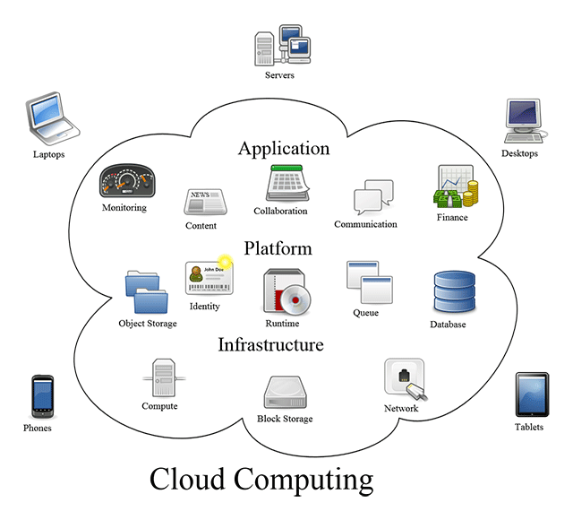

**S R I R A M**

**BY**

**SRIRAM**

Preface

I have been involved in IT Software development since 1997. I have a unique combination of process, technical and industrial skills. As an Enterprise Architect, I have expert level of knowledge in agile and technology practices such as AWS, Azure, DevOps, java, Hadoop, SharePoint & .Net with this combination I can help process and technology people, understand the world.

Worked in India, USA, and UK which creates a global experience and awarded as a best Enterprise Architect. Dedicated “Cloud Champion” book to my family members & friends. This Guide made handy and recollect everything at one shot.

Organization of this Book

Cloud Computing Champion is designed to make you to success in the interview by providing valuable questions on various topics along with the practice questions to achieve Cloud Computing Certification. The progressive elaboration of Web Developer knowledge towards an Cloud Computing knowledge is awesome. Enjoy Reading!

Table of Contents

|  |  |
| --- | --- |
| Lesson 1 INTRODUCTION TO CLOUD COMPUTING | 3 |
| Lesson 2 CHARECTERISTICS OF CLOUD COMPUTING | 10 |
| Lesson 3 SERVICE MODELS OF CLOUD COMPUTING | 14 |
| Lesson 4 DEPLOYMENT MODELS OF CLOUD COMPUTING | 26 |
| Lesson 5 ADVANTAGES OF CLOUD COMPUTING | 31 |
| Lesson 6 CLOUD COMPUTING QUIZ | 34 |

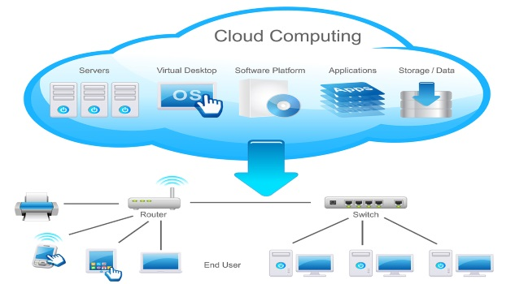

# Cloud Computing

Topics to Discuss

* Introduction to Cloud Computing
* Traditional – IT Deployment Models
* Server Virtualization
* What is Cloud Computing?
* Characteristics of Cloud Computing
  + On-demand self-service
  + Broad network access
  + Resource Pooling
  + Rapid elasticity
  + Measured Service
* Service Models of Cloud Computing
  + Software as a Service(SaaS)
  + Platform as a Service(Paas)
  + Infrastructure as a Service(IaaS)
* Deployment Models of Cloud Computing
  + Private Cloud
  + Community Cloud
  + Public Cloud
  + Hybrid Cloud
* Advantages of Cloud Computing

## Lesson 1 Introduction to Cloud Computing

What are the Traditional IT Services Deployment Models?

Traditional deployment models for IT services available before cloud:

* On Premises Solutions (Customer Premises Equipment)
* Colocation or 'Colo' services

What are the On Premises Solution Characteristics?

* All equipment is located in your building
* All equipment is owned by you
* There are clear lines of demarcation - everything in the building is your responsibility, the connections between offices are your network service providers responsibility

Equipment is Capital Expense (CapEx)

* New equipment will typically take over a week to deploy
* Equipment requires technology refreshes
* You need to consider redundancy

How many number of tiers available in Data centers?

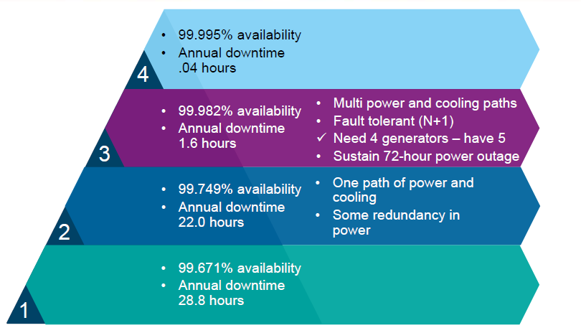

What is Colocation Center | Colocation Facilities | Colo?

* A colocation center or "Colo", is a data center location where the owner of the facility rents out space to external customers
* The facility owner provides power, cooling, and physical security for their customer's server, storage, and network equipment
* Independent Colo provides such as Equinix offer customers multiple network connectivity options through a choice of network service providers
* Network service providers will also typically peer with each other in colo facilities

What is Colo Solution Characteristics?

* Your server infrastructure is located in the external “Colo” building
* Your user desktop will still be in your offices
* The “Colo” provider owns the data center facility and is responsible for providing highly available power, cooling and physical security according to the terms of the Service Level Agreement
* You own your own server, storage, and networking equipment within the “Colo” facility
* The connections between your offices and the “Colo” are your network service providers responsibility
* Your equipment within the “Colo” facility is a CapEx cost
* The monthly colo hosting fees are an OpEx expense
* New equipment will typically take over a week to deploy
* Equipment requires technology refreshes
* You need to consider redundancy for the hardware you own, byt power and cooling is handled by the facility

What is Server Virtualization? How would you handle effectively?

* Server virtualization is a virtualization technique that involves partitioning a physical server into a number of small, virtual servers with the help of virtualization software. In server virtualization, each virtual server runs multiple operating system instances at the same time.
* Server Virtualization is one of the main enablers of cloud computing. It allows for resource pooling where multiple customers share the underlying server hardware. Server Virtualization has been around a lot longer than Computing though

Before Virtualization – Server Maintenance

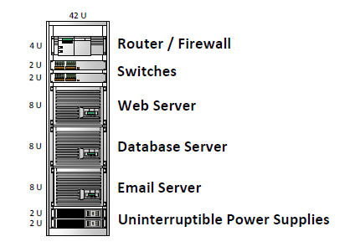

* Sever utilization (CPU, RAM, NIC etc.) around 15%
* Pay for each server separately and they are all using power space and cooling

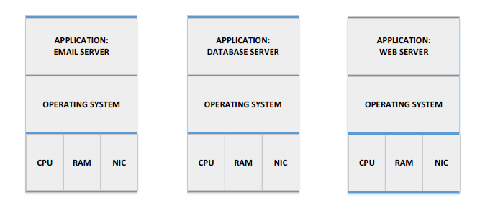

Don’t follow the bad practices

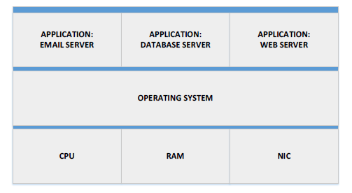

* Putting multiple applications on the same server would improve utilization
* But is very bad practice, because if problem arises with any one of the applications they will all get affected

How to rescue the Server Virtualization?

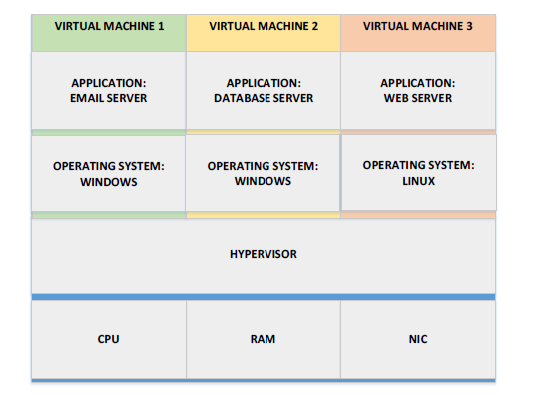

What is Hypervisor? What are its types?

A hypervisor is a function which abstracts -- isolates -- operating systems and applications from the underlying computer hardware. This abstraction allows the underlying [host machine](http://searchservervirtualization.techtarget.com/definition/host-virtual-machine-host-VM) hardware to independently operate one or more [virtual machines](http://searchservervirtualization.techtarget.com/definition/virtual-machine) as guests, allowing multiple guest VMs to effectively share the system's physical compute resources, such as [processor](http://whatis.techtarget.com/definition/processor) cycles, memory space, network bandwidth and so on. A hypervisor is sometimes also called a virtual machine monitor.

Type 1 Hypervisor

It runs directly on the system hardware

Type 2 Hypervisor

It runs on the top of a host operating system

Explain the different types of Hypervisor?

There are two types of Hypervisor namely Type 1 Hypervisor Vs Type 2 Hypervisor

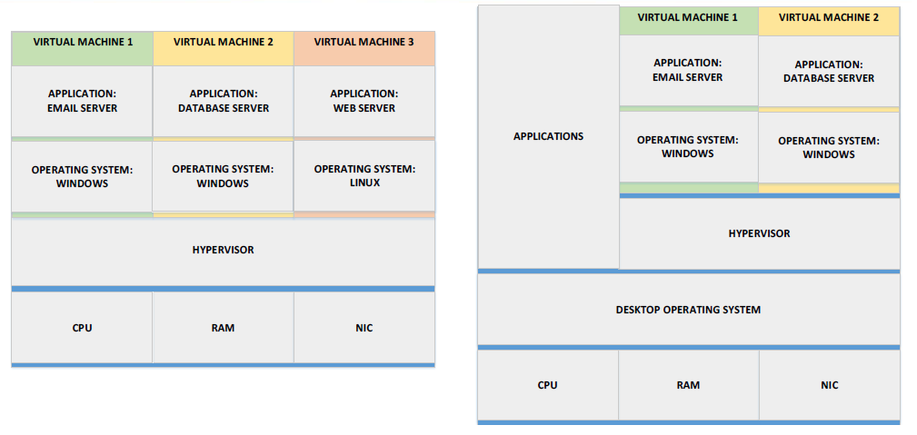

Type 1 Hypervisor

It runs directly on the system hardware

* VMware ESXi
* Microsoft Hyper-V
* Red Hat KVM
* Oracle VM Server
* Citrix XenServer

Type 2 Hypervisor

It runs on the top of a host operating system

* VMware workstation, Player & Fusion
* VirtualBox
* QEMU
* Parallels

What is Cloud Computing?

The National Institute of Standards and Technology (NIST) provided the industry standard definition of Cloud Computing in 2011

Cloud computing is a model for enabling ubiquitous, convenient, on-demand network access to a shared pool of configurable computing resources (e.g., networks, servers, storage, applications, and services) that can be rapidly provisioned and released with minimal management effort or service provider interaction. - NIST

This cloud model is composed of five essential characteristics, three service models, and four deployment models.

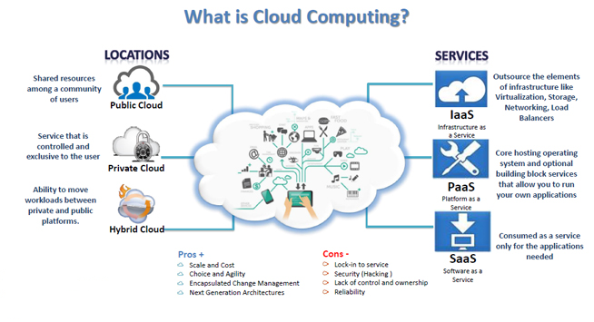

What generally people think about Cloud Computing?

People will normally think Cloud Computing as "IT services which are located somewhere else". But Colo facilities are off premises, and they are not cloud and private cloud deployments are often on premises. (or)

Cloud Computing often referred to as “the cloud”, in simple terms means storing or accessing your data and programs over the internet rather than your own hard drive. (or)

Practice of using a network of remote servers hosted on the Internet to store, manage, and process data, rather than a local server or a personal computer is called Cloud Computing.

Companies offering these computing services are called cloud providers and typically charge for cloud computing services based on usage, similar to how you are billed for water or electricity at home. E.g.: AWS, AZURE, IBM Bluemix, GOOGLE CLOUD

What are the reasons for moving to Cloud Computing? Why Organization moving towards Cloud Computing?

The main reason for going cloud is: -

* Free from Maintenance i.e., You do not have to maintain or administer any infrastructure for the same.
* Lower Computing Cost
* Improved Performance
* Reduced Software Cost
* Instant Software Updates
* Unlimited Storage Capacity i.e., It will never run out of capacity, since it is virtually infinite.
* Increased Data Reliability
* Device Independence and the “always on! anywhere and any place” i.e., You can access your cloud based applications from anywhere, you just need a device which can connect to the internet.

Why Cloud Computing?

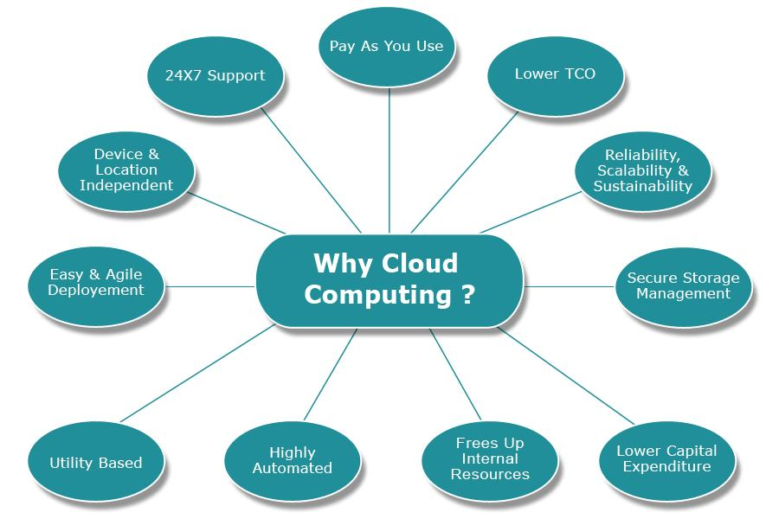

## Lesson 2 Characteristics of Cloud Computing

What are the 5 essential Characteristics of Cloud Computing?

The 5 essential characteristics of cloud computing are: -

* On-demand self-service
* Broad network access
* Resource Pooling
* Rapid elasticity
* Measured Service

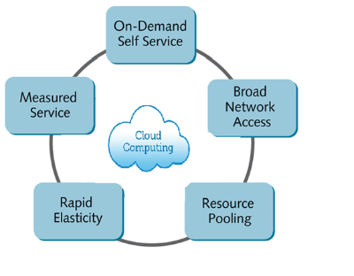

On-demand self-service. A consumer can unilaterally provision computing capabilities, such as server time and network storage, as needed automatically without requiring human interaction with each service provider. - NIST

Broad network access. Capabilities are available over the network and accessed through standard mechanisms that promote use by heterogeneous thin or thick client platforms (e.g., mobile phones, tablets, laptops, and workstations). - NIST

Resource pooling. The provider’s computing resources are pooled to serve multiple consumers using a multi-tenant model, with different physical and virtual resources dynamically assigned and reassigned according to consumer demand. There is a sense of location independence in that the customer generally has no control or knowledge over the exact location of the provided resources but may be able to specify location at a higher level of abstraction (e.g., country, state, or datacenter). Examples of resources include storage, processing, memory, and network bandwidth. - NIST

Rapid elasticity. Capabilities can be elastically provisioned and released, in some cases automatically, to scale rapidly outward and inward commensurate with demand. To the consumer, the capabilities available for provisioning often appear to be unlimited and can be appropriated in any quantity at any time. - NIST

Measured service. Cloud systems automatically control and optimize resource use by leveraging a metering capability1 at some level of abstraction appropriate to the type of service (e.g., storage, processing, bandwidth, and active user accounts). Resource usage can be monitored, controlled, and reported, providing transparency for both the provider and consumer of the utilized service. - NIST

Give Comparison with On-Prem and Colo?

The time to deploy a new workload in an On-Prem or Colo deployment is typically at least a weak because of the following reasons:

* The purchase needs to be approved and the server ordered
* The server needs to be delivered
* It needs to be physically racked up and cabled
* The server team need to install and configure the OS, patches, any standard software and the applications
* The network team need to configure switches, routers and firewalls
* The storage team need to configure the storage system and SAN switches
* The lead time is quicker when provisioning virtual machines but it still takes time for the development teams to manually complete their tasks

How Rapid Elasticity can be applicable to the organization?

* Servers can be quickly provisioned and decommissioned based on the current demand
* Elasticity allows customers to achieve cost savings and is often a crore justification for adoption

Suppose If 10 servers are required for a 3-month project, the company can provision them within minutes, pay a small monthly OpEx fee to run them rather than a large upfront CapEx cost, and decommission them at the end of 3 months? How will provide solution?

Solution: Use software for a short term instead of buying a permanent license.

Compare Traditional On-Premise Solution & Cloud Solution on basis of network access?

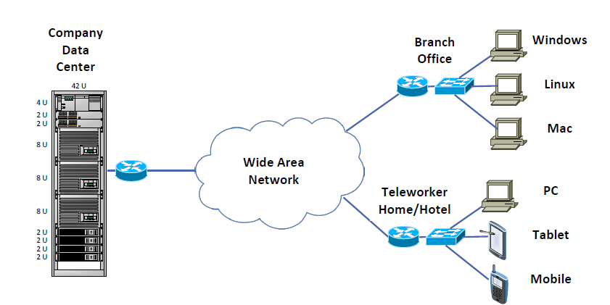

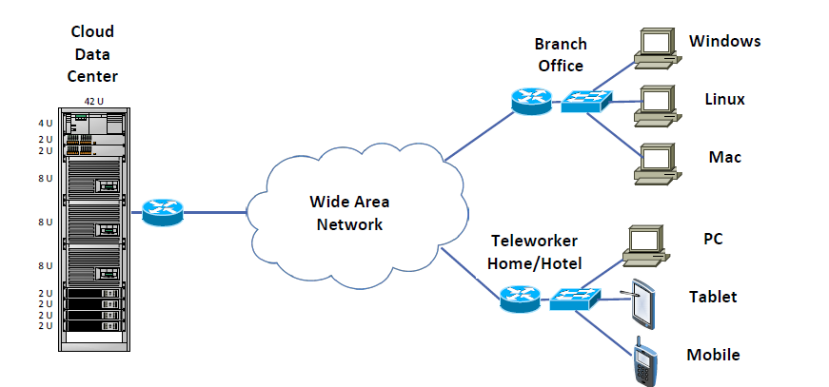

How Measured Services can be utilized in Cloud environment? How the usage can be calculated for billing purposes?

* Billing will typically be monthly, and is an OpEx cost from the customer's viewpoint
* The choice of Pay As You Go or fixed monthly plans is often available
* Exactly what is billed depends on what Service Model is being used for - IaaS |PaaS | SaaS

How Resource Pooling can be done effectively?

Resource Pooling With respect to Memory & Processing

Hypervisor demo will give the clarity how the memory processing can be done effectively.

Resource Pooling With respect to For Storage

Further savings can be made through storage efficiency techniques such as thing provisioning, deduplication and compression.

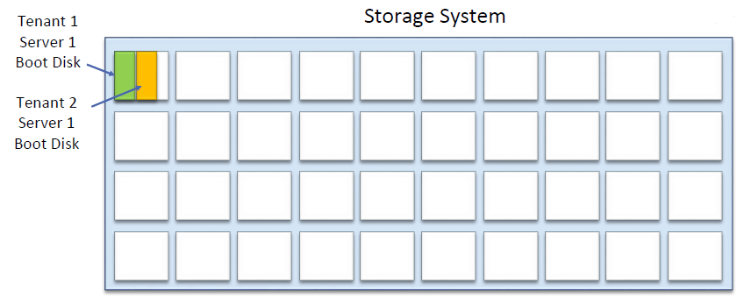

Resource Pooling With respect to Networking and Services

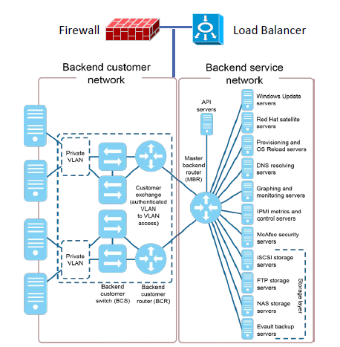

## Lesson 3 Service Models of Cloud Computing

What are the 3 Service Models of Cloud Computing? Give an Example?

* The NIST define three Service Models of how cloud services can be offered:
  + IaaS Infrastructure as a Service –> Involved: Network Architects
  + PaaS Platform as a Service –> Involved: Application Developers
  + SaaS Software as a Service –> Involved: End Users
* Large cloud server providers offer multiple models
* The three models define where the customer and provider areas of responsibility are, and at what level the customer gains access.
* The three models build on top of one another

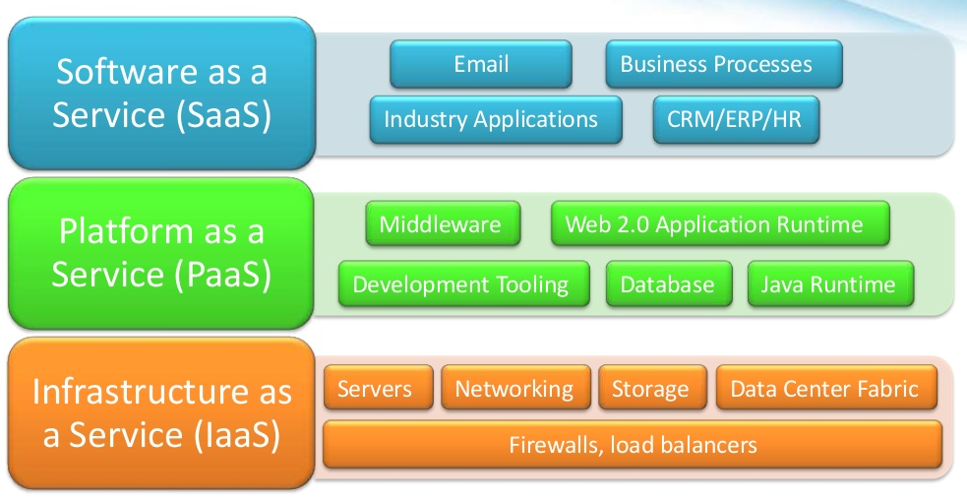

List the Service Model responsibilities of Cloud Computing?

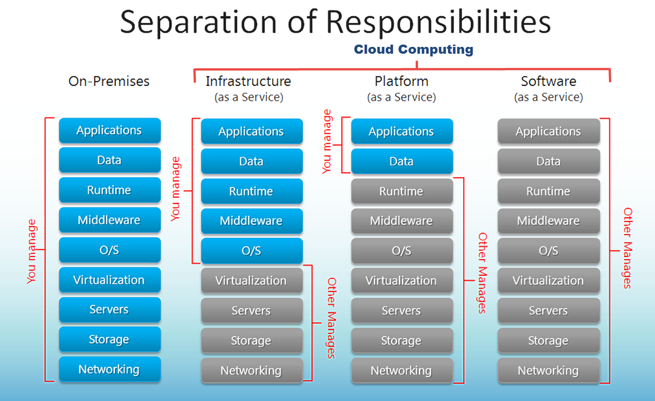

Showcase the Data Center Stack through the different Service Models?

Data Center Stack View

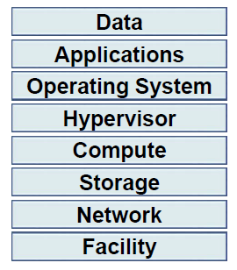

On Premise View

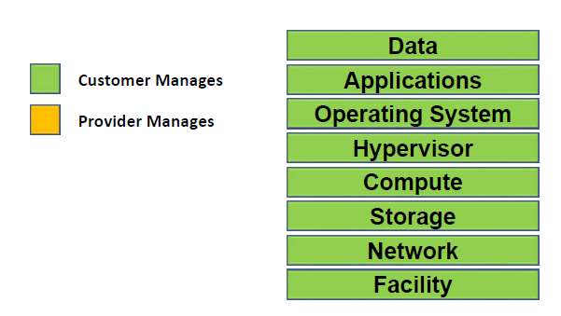

Colo View

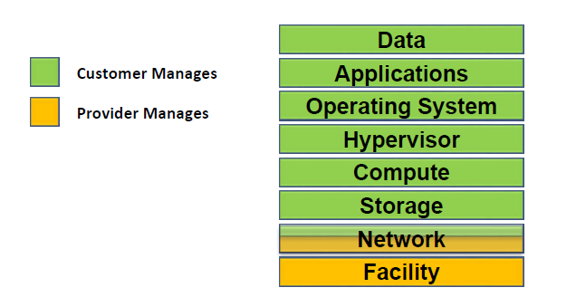

IaaS Model

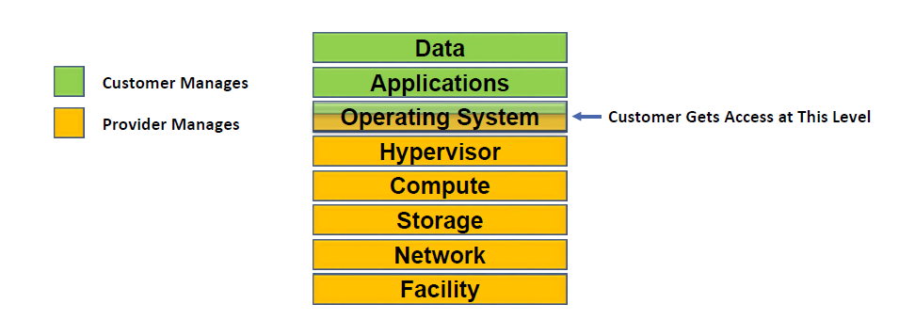

PaaS Model

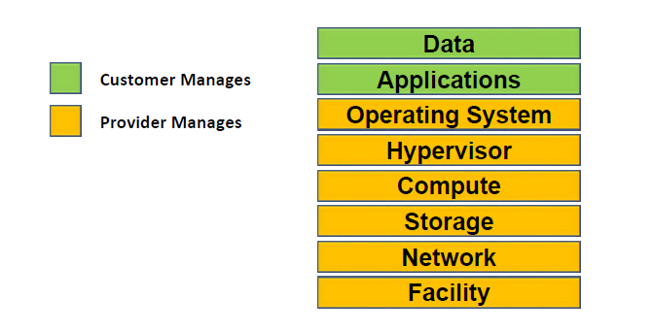

SaaS Model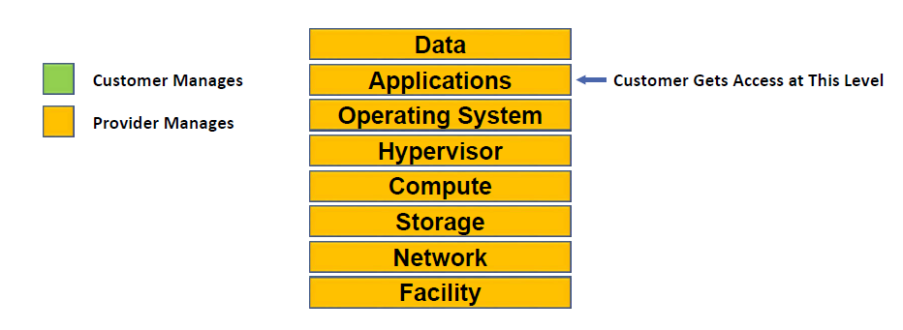

Give detailed explanation of the Service Models of Cloud Computing?

Software as a Service (SaaS). The capability provided to the consumer is to use the provider’s applications running on a cloud infrastructure2. The applications are accessible from various client devices through either a thin client interface, such as a web browser (e.g., web-based email), or a program interface. The consumer does not manage or control the underlying cloud infrastructure including network, servers, operating systems, storage, or even individual application capabilities, with the possible exception of limited user-specific application configuration settings. - NIST

Software-as-a-service (SaaS) is a method for delivering software applications over the Internet, on demand and typically on a subscription basis. With SaaS, cloud providers host and manage the software application and underlying infrastructure and handle any maintenance, like software upgrades and security patching. Users connect to the application over the Internet, usually with a web browser on their phone, tablet or PC.

The Key features are: -

* SaaS vendors provide users with software and applications on a subscription model.
* Users do not have to manage, install, or upgrade software; SaaS providers manage this.
* Data is secure in the cloud; equipment failure does not result in loss of data.
* Use of resources can be scaled depending on service needs.
* Applications are accessible from almost any Internet-connected device, from virtually anywhere in the world.

SaaS Examples: Microsoft Office 365, Salesforce.com, Intuit, Adobe Creative Cloud & Gmail

SaaS Billing:

* SaaS will typically have a monthly fee per user
* Multiple pricing tiers may be offered based on usage E.g. Microsoft Office 365

Platform as a Service (PaaS). The capability provided to the consumer is to deploy onto the cloud infrastructure consumer-created or acquired applications created using programming 3 languages, libraries, services, and tools supported by the provider.3 The consumer does not manage or control the underlying cloud infrastructure including network, servers, operating systems, or storage, but has control over the deployed applications and possibly configuration settings for the application-hosting environment. - NIST

Platform-as-a-service (PaaS) refers to cloud computing services that supply an on-demand environment for developing, testing, delivering and managing software applications. PaaS is designed to make it easier for developers to quickly create web or mobile apps, without worrying about setting up or managing the underlying infrastructure of servers, storage, network and databases needed for development.

The Key features are: -

* PaaS provides a platform with tools to test, develop, and host applications in the same environment.
* Enables organizations to focus on development without having to worry about underlying infrastructure.
* Providers manage security, operating systems, server software, and backups.
* Facilitates collaborative work even if teams work remotely.

Examples: AWS Elastic Beanstalk, Microsoft Azure, Google Apps, Salesforce Force.com &

IBM Bluemix

PaaS Billing: PaaS will typically be billed based on memory usage i.e., IBM Bluemix

Infrastructure as a Service (IaaS). The capability provided to the consumer is to provision processing, storage, networks, and other fundamental computing resources where the consumer is able to deploy and run arbitrary software, which can include operating systems and applications. The consumer does not manage or control the underlying cloud infrastructure but has control over operating systems, storage, and deployed applications; and possibly limited control of select networking components (e.g., host firewalls). - NIST

The most basic category of cloud computing services. With IaaS, you rent IT infrastructure—servers and virtual machines (VMs), storage, networks, operating systems—from a cloud provider on a pay-as-you-go basis.

The Key features are: -

* Instead of purchasing hardware outright, users pay for IaaS on demand.
* Infrastructure is scalable depending on processing and storage needs.
* Saves enterprises the costs of buying and maintaining their own hardware.
* Because data is on the cloud, there is no single point of failure.
* Enables the virtualization of administrative tasks, freeing up time for other work.

What are the IaaS flavours? Explain each flavours in detail?

* Cloud Providers will often offer three distinct flavours of IaaS compute:
* Virtual machines on Shared physical servers
* Virtual machines on dedicated physical servers
* Dedicated bare-metal physical server
* Customers can mix and match between three types

Virtual machines on Shared physical servers

* With virtual machines on shared physical servers, different customers can have their virtual machines on the same shared underlying physical servers
* This is the least expensive option
* It has the lease amount of options in terms of how many vCPUs, RAM and storage
* The virtual machines can usually be provisioned more quickly than the dedicated options
* This is the most commonly deployed option

Virtual machines on Dedicated physical servers

* With Virtual machines on dedicated physical servers, a customer is guaranteed that the underlying physical server is dedicated to them
* This is a substantially more expensive option than virtual machines on shared physical servers
* There are typically more options in terms of how many vCPUs, RAM and storage
* The customer may be required to sign a minimum length contract

Dedicated bare-metal physical server

* With dedicated bare-metal servers, a customer is given access to their own physical servers
* A hypervisor is not installed and managed by the cloud provider
* The customer can either install an operating system directly on the server, or can install and manage their own hypervisor
* This is the most expensive option
* It typically has the most options in terms of how many vCPUs, RAM and storage
* The customer may be required to sign a minimum length of contract
* AWS does not have this option

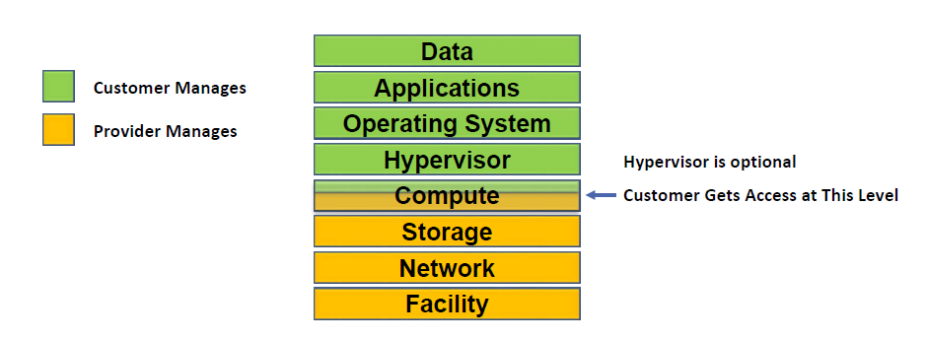

Virtual machines on dedicated physical servers Vs Dedicated bare-metal physical server

* The most common reason to choose virtual machines on dedicated physical servers is for compliance
* Dedicated bare-metal servers can fulfil the same compliance requirements
* Both require dedicated physical servers for the customer so that cost is typically similar
* A reason a customer may prefer virtual machines on dedicated physical servers is if they don't have expertise in-house to manage the hypervisor

IaaS Network Options

* Customers may be offered similar options for shared or dedicated firewalls and load balancers
* Customers can typically connect into the Cloud Provider's data center over the Internet and or via direct network connection

IaaS Storage Options

* Customers will typically have the option of local hard drives in the server, or external SAN or NAS storage
* The customer also has the option of managing their own storage operating system on a virtual machine or bare-metal server
* The customer may be able to install their own storage operating system in the cloud provider's data center

IaaS Management Options

* The customer can manage their servers (to install applications and patches etc.) through standard remote management methods, such as Remote Desktop for Windows Servers and Secure Shell for Linux
* An API is also typically available to allow for automation of common tasks such as provisioning a new virtual machine

IaaS Application Options

* The customer may also have the option of applications such as Microsoft SQL or Antivirus
* They can either install the application and look after the licensing themselves (CapEx), or have the Cloud Provider do it for them (OpEx)
* The Cloud Provider may also offer to manage the application

IaaS Billing

* For virtual machines on shared physical servers, CPU and RAM will typically be billed only when the virtual machine is powered on - the Physical CPU and RAM in the underlying server hardware will be available for use by other customers when the virtual machine is powered off
* Network bandwidth will be billed as it is used. Some usage will typically be bundled with monthly plans
* Data Storage will typically be billed whether the virtual machine is powered on or off, as the data will always be there and taking up physical storage space
* Optional Software extras such as Windows OS or SQL Server will be billed as a flat monthly fee

Examples: AWS EC2, Telstra IaaS

How Infrastructure as a Service (IaaS) will be implemented for an Ecommerce Web application?

Consider 3 Tier Ecommerce Application with Front End | Middleware | Back End going to deploy

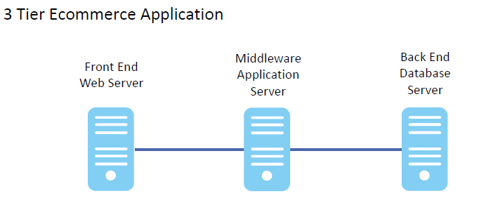

Design Compute & Storage Setup

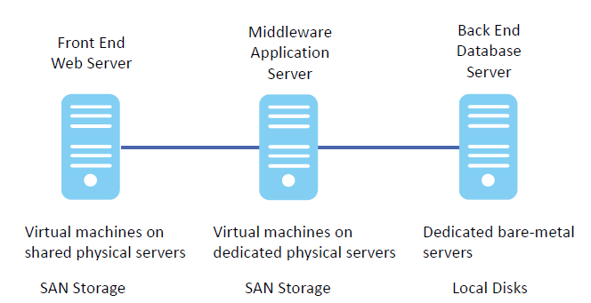

Networking Setup

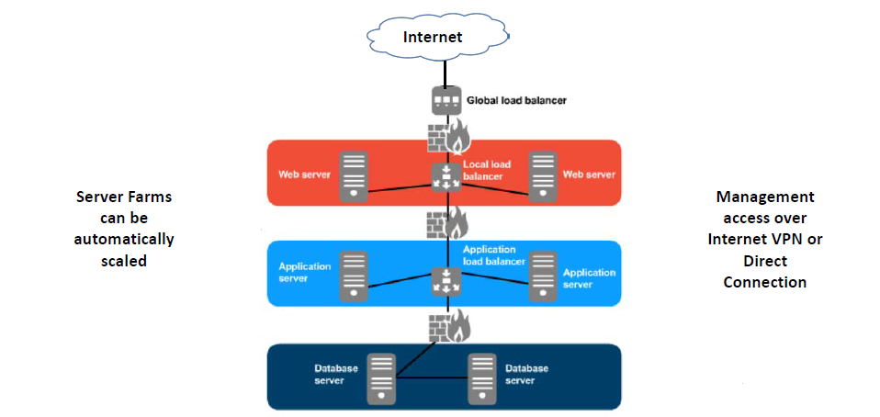

Disaster Recovery Setup

* If the data center is lost, you will be able to recover to a different location from backup
* In this case, you will lose all the new data since the last backup was taken (recovery point objective)
* It could take a significant amount of time to deploy the infrastructure in the new location and restore the data (Recovery Time Objective)
* You may want to provision a Disaster Recovery solution to reduce the RPO and RTO

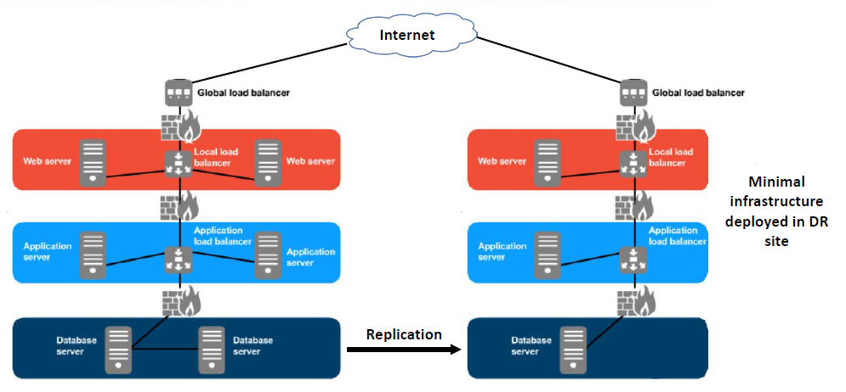

Backup Mechanism

* Like On-Premise solution, you need to consider the backups for cloud environment
* The Cloud Provider will not automatically take the backup
* The Cloud Provider's data center is a hardened facility with no single points of failure, but this does not protect your data against regional disasters or data corruption
* You have network connectivity to the cloud facility, so you can back up back to your office using your existing backup solution
* You can also use the Cloud Provider's storage
* Data should always be backed up to an offsite location

## Lesson 4 Deployment Models of Cloud Computing

What are the 4 Deployment Models of Cloud Computing?

The NIST define three Deployment Models of Cloud Computing:

* Public Cloud
* Private Cloud
* Hybrid Cloud
* Community Cloud

Public cloud. The cloud infrastructure is provisioned for open use by the general public. It may be owned, managed, and operated by a business, academic, or government organization, or some combination of them. It exists on the premises of the cloud provider. – NIST

Public clouds are owned and operated by a third-party [cloud service provider](https://azure.microsoft.com/en-in/overview/choosing-a-cloud-service-provider/), which deliver their computing resources like servers and storage over the Internet. Microsoft Azure is an example of a public cloud. With a public cloud, all hardware, software and other supporting infrastructure is owned and managed by the cloud provider. You access these services and manage your account using a web browser.

Examples

All the cloud providers such as AWS, Microsoft Azure, IBM Bluemix, Salesforce, etc.,

The most common deployment model

Private cloud. The cloud infrastructure is provisioned for exclusive use by a single organization comprising multiple consumers (e.g., business units). It may be owned, managed, and operated by the organization, a third party, or some combination of them, and it may exist on or off premises. - NIST

Private Cloud works the same way as Public Cloud, but these services are provided to internal business units instead of to external public enterprises

A private cloud refers to cloud computing resources used exclusively by a single business or organization. A private cloud can be physically located on the company’s on-site datacenter. Some companies also pay third-party service providers to host their private cloud. A private cloud is one in which the services and infrastructure are maintained on a private network.

Examples: US DOD, Indian Military, Most of govt bodies and High revenue business

All Companies with Private cloud don't usually advertise the fact because it's, well, private.

A well-known example is the US Department of Defense on Private cloud provided by AWS. Private cloud owned, managed and operated by third party

Note: Be Aware with Service Provider

Public Cloud IaaS providers will sometimes market Dedicated Servers as Private Cloud because the underlying server are dedicated for a particular customer. This is not true Private Cloud however as the supporting network infrastructure is shared

Hybrid cloud. The cloud infrastructure is a composition of two or more distinct cloud infrastructures (private, community, or public) that remain unique entities, but are bound together by standardized or proprietary technology that enables data and application portability (e.g., cloud bursting for load balancing between clouds). - NIST

Hybrid clouds combine public and private clouds, bound together by technology that allows data and applications to be shared between them. By allowing data and applications to move between private and public clouds, hybrid cloud gives businesses greater flexibility and more deployment options.

Companies with limited Private Cloud infrastructure may 'cloud burst' into Public Cloud for additional capacity when required

A company Cloud also have Private Cloud at their main site and use Public Cloud for their Disaster Recovery location

Community cloud. The cloud infrastructure is provisioned for exclusive use by a specific community of consumers from organizations that have shared concerns (e.g., mission, security requirements, policy, and compliance considerations). It may be owned, managed, and operated by one or more of the organizations in the community, a third party, or some combination of them, and it may exist on or off premises. – NIST

This is similar to a traditional extranet, but with full shared data center services instead of just network connectivity between On-Premise Offices.

This is the least common deployment model.

How Private Cloud differ than On-Premise?

Private Cloud fulfils the Cloud ‘Essential Characteristics'

* On-Demand Self-Service
* Rapid Elasticity
* Broad Network Access
* Resource Pooling
* Measured Service

With the Traditional On-Premises model, a business unit orders a new server by raising a ticket with the IT department. The server is then provisioned and configured by the server, network, and storage teams as separate manual process.

With Private Cloud, a business unit orders a new server typically through a web portal. The server is then completely automatically provisioned without requiring manual intervention.

The company will use automation software such as BMC, CA Technologies, or Cisco UCS Director.

Private Cloud is most suitable for large companies where the long-term ROI and efficiency gains can outweigh the initial effort and cost to set up the infrastructure and automated workflows.

Cloud Provider Comparison

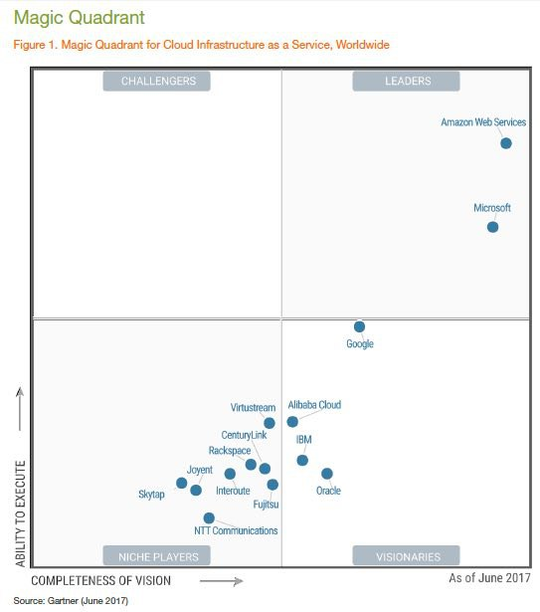

## Lesson 5 Advantages of Cloud Computing

What are the advantages of Cloud Computing?

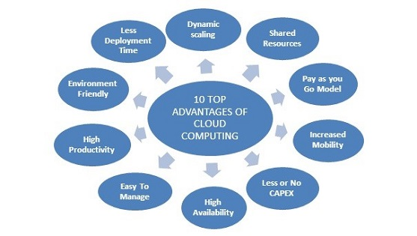

Scalability

* Cloud Computing provides business with the ability to regulate the service in accordance with their current requirements:
* Scale capacity up and down as needed
* Infinite computing capacity on demand
* Flexibility through cloud bursting

Business Agility

* Ability to handle expected or unexpected changes in load
* Reduced time to deploy an application into production

Cost Efficiency

* The customer pays just for what they need, resulting in directly proportional costs
* The customer avoids provisioning for the peak as a permanent fixture
* Move from a large upfront CapEx cost to a comparatively small monthly OpEx cost
* ICT costs are more transparent to the business
* The customer does not have depreciable hardware assets
* Technology refresh is the responsibility of the Cloud Provider
* The provider passes hardware maintenance costs onto the customer as part of the predictable monthly fee, there are no unexpected costs

Competitive Advantage

* Organizations can respond quickly to evolving market trends and focus on growing their core business
* Reducing capital spent on infrastructure releases funds to invest in innovation or other priority areas

Productivity

* IT staff can focus more on strategic decisions and developing and improving core applications rather than maintaining or troubleshooting in-house ICT

Availability & Reliability

* All major Cloud Providers facilities are located in hardened data centers with redundant power, no single point of failure and onsite security
* The service will be certified to the relevant industry standards such as ISO 9001 (Quality) and 27001 (Security)
* The data center is built by facilities, server, networking and storage qualified specialists according to best practice
* Check the Service Level Agreement to see what is guaranteed and the compensation if the SLA is not met

Cost

* The advantages are all great to have, but a decision to deploy Cloud Computing usually comes down to the overall long-term cost
* The TCO of maintaining an On Premises solution should be compared to the TCO of maintaining a Cloud equivalent, and the advantages and disadvantages of each factored in when making the final decision
* It is not a wither or decision. The majority of companies who use Cloud services will have a mix of On Premise and Cloud solutions

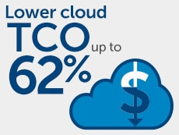

Data Center Costs

* CapEx Cost: Hardware Procurement
* OpEx Cost: Rack space, Power and Cooling, On-going management

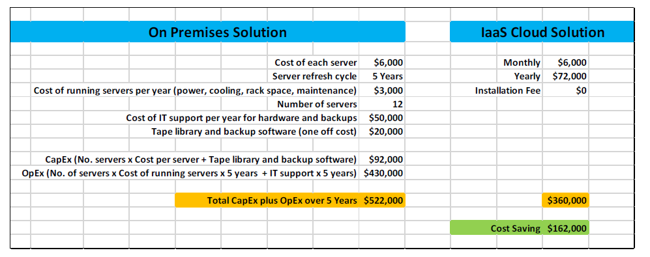

Finally, we can conclude 30% of cost savings with zero down time and high performance. Organization can invest in Cloud to achieve the greater benefits.

What are the benefits of Cloud Computing?

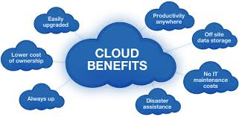

## Lesson 6 Cloud Computing Quiz

True or false: Cloud computing is just a buzzword that’s been dreamt up by a marketing team to sell their products.

Ans: False

True or False: All cloud solutions fit into one of the three service models, IaaS, PaaS or SaaS. Anything not fitting exactly into these service models is not a cloud solution.

Ans: False

Cloud service models are a continuum, products could align with the service models, or fall somewhere in-between.

What type of cloud service model does Gmail represent?

1. Infrastructure as a Service(IaaS),
2. Platform as a Service(PaaS)
3. Software as a Service(SaaS)

Ans: Software as a Service

Gmail is an example of Software as a Service.

Given that the solution meets your business requirements, which cloud service model should be most cost effective?

1. Infrastructure as a Service(IaaS),
2. Platform as a Service(PaaS)
3. Software as a Service(SaaS)

Ans: Software as a Service

Which of the essential characteristics of the cloud refers the the clouds ability to expand and contract to meet your demands?

1. On-demand self-service,
2. Broad network access,
3. Resource pooling,
4. Rapid elasticity,
5. Measured service

Ans: Rapid elasticity

What is the meaning of the essential characteristic ‘On demand self-service’?

1. Capabilities can be elastically provisioned and released, in some cases automatically, to scale rapidly outward and inward commensurate with demand. To the consumer, the capabilities available for provisioning often appear to be unlimited and can be appropriated in any quantity at any time
2. A consumer can unilaterally provision computing capabilities such as server time and network storage, as needed automatically without requiring human interaction with each service provider
3. Capabilities are available over the network and accessed through standard mechanisms that promote use by heterogeneous thin or thick client platforms (e.g. Mobile Phone, Tablets, Laptops and workstations)

Ans: A consumer can unilaterally provision computing capabilities such as server time and network storage, as needed automatically without requiring human interaction with each service provider

True or false: An essential characteristic of the cloud is its ability to be provisioned within your own Data Centre before moving to the cloud.

Ans: False

True or false: A cloud deployment model is the organizational structure or procurement method of cloud computing.

Ans: True

Is it possible to have private data in public cloud?

Ans: True

What type of deployment model accounts for the majority of the worlds cloud computing?

1. Private Cloud,
2. Community Cloud,
3. Public Cloud,
4. Hybrid Cloud

Ans: Public Cloud

Amazon Web Services (AWS) is the biggest supplier of cloud computing in the world today. AWS is public IaaS and PaaS cloud.

Traditional IT Deployments

Which of these is a capital expenditure for an enterprise who use a Colo facility?

1. The power and cooling in the facility
2. The servers in the facility
3. The network connections in the facility
4. The SLA with the facility

Ans: The servers in the facility

The customer provides their own server equipment, this is a CapEx cost

If a Tier 3 data center requires 5 generators to provide enough power, what is the minimum number of generators which should be installed?

1. 5
2. 6
3. 10
4. 11

Ans:6

A Tier 3 data center requires N+1 power

Which of these is a Type 1 Hypervisor?

1. SUSE Linux
2. VMware Workstation
3. Citrix XenServer
4. Parallels

Ans: Citrix XenServer

Citrix XenServer is a Type 1 Hypervisor

What is installed on the server hardware in a vSphere environment?

1. Microsoft Windows
2. Red Hat Linux
3. VMware Workstation
4. ESXi

Ans: ESXi

ESXi is the Type 1 Hypervisor which is installed on the server hardware in a VMware vSphere environment

Defining Cloud - Essential Characteristics

Which authority published the de facto definition of Cloud Computing?

1. IETF
2. ITU
3. ISO
4. NIST

Ans: The National Institute of Standards and Technology published the definition of Cloud Computing

Which Cloud essential characteristic enables organizations to deploy applications quicker than they could with a traditional On Premises solution?

1. On-Demand Self-Service
2. Rapid Elasticity
3. Resource Pooling
4. Measured Service

Ans: On-Demand Self-Service

Auto scaling is an example of which Cloud essential characteristic? Choose the one best answer.

1. On-Demand Self-Service
2. Rapid Elasticity
3. Broad Network Access
4. Resource Pooling

Ans: Rapid Elasticity

Rapid Elasticity means quickly scaling services in or out.

Which of these is NOT a typically pooled resource in a Cloud environment?

1. Data center
2. Virtual machine
3. Server
4. Firewall

Ans: Virtual machine

Virtual machines are owned by an individual tenant and not share

Cloud Service Models - IaaS, PaaS and SaaS

With IaaS virtual machines on shared or dedicated servers, at which level does the customer get access?

1. Compute
2. Operating System
3. Custom Environment
4. Application

Ans: Operating System

With IaaS virtual machines on dedicated bare-metal servers, at which level does the customer usually get access?

1. Compute
2. Operating System
3. Custom Environment
4. Application

Ans: Compute

With PaaS, at which level does the customer get access?

1. Compute
2. Operating System
3. Custom Environment
4. Application

Ans: Custom Environment

With SaaS, at which level does the customer get access?

1. Compute
2. Operating System
3. Custom Environment
4. Application

Ans: Application

Which Cloud option would an enterprise select for their virtual machines if regulatory compliance meant they could not use multi-tenant compute, and they did not have IT staff with Hypervisor experience?

1. Virtual machines on shared physical servers
2. Virtual machines on dedicated physical servers
3. Dedicated bare-metal servers
4. Platform as a Service

Ans: Virtual machines on dedicated physical servers

This fulfils the compliance requirement without the company requiring Hypervisor expertise

Which Data Protection service is typically enabled as standard by the Cloud Provider?

1. Snapshots
2. Backup to disk
3. Disaster Recovery
4. None

Ans: None

You need to provision Data Protection as part of your design, it is not done for you by default.

Which of these is an example of PaaS?

1. AWS Elastic Beanstalk
2. AWS S3
3. AWS EC2
4. AWS IAM

Ans: AWS Elastic Beanstalk

AWS Elastic Beanstalk is a PaaS service.

Which service allows you to run VDI at a Cloud Provider's facility?

1. DaaS
2. BaaS
3. DRaaS
4. VaaS

Ans: DaaS

Desktop as a Service is Cloud based Virtual Desktop Infrastructure

Cloud Deployment Models - Public, Private and Hybrid Cloud

A company owns and maintains their own data center infrastructure. When a new server is provisioned the server, network and storage teams configure the settings. What deployment model is this?

1. On Prem
2. Colo
3. Public Cloud
4. Private Cloud
5. Hybrid Cloud

Ans: On Prem

A provider owns and maintains a data center for another company. The company's business units provision virtual machines through an automated portal. What deployment model is this?

1. On Premises
2. Colo
3. Public Cloud
4. Private Cloud
5. Hybrid Cloud

Ans: Private Cloud Deployment

A provider owns and maintains a data center for other companies. The company's business units provision virtual machines through an automated portal. What deployment model is this?

1. On Premises
2. Colo
3. Public Cloud
4. Private Cloud

Ans: Public Cloud Deployment

A company owns and maintains their own data center infrastructure. The company's business units provision virtual machines through an automated portal. Some business units provision virtual machines on AWS. What deployment model is this? Choose the single best answer.

1. On Premises
2. Colo
3. Public Cloud
4. Private Cloud
5. Hybrid Cloud

Ans: Hybrid Cloud

Advantages of Cloud Computing and Calculating TCO

Cloud Computing is awesome! But does it mean you're going to be replaced by robots?

No way Jose!

Yes, Skynet is here. The end is nigh.

Ans: Yes, Skynet is here. The end is nigh.

